
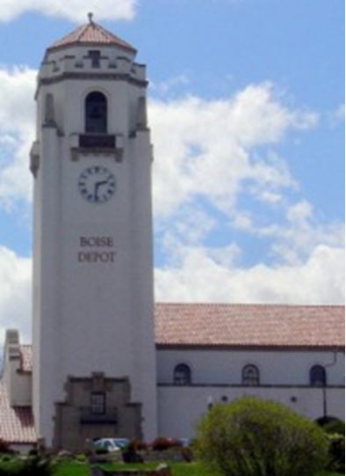




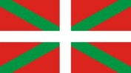
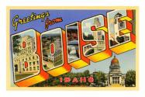

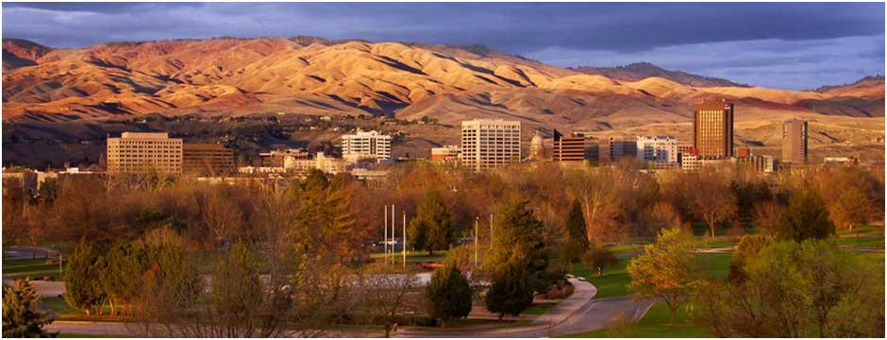
REGION II FALL ROC MEETING
September 16-17, 2016
Albertson’s Corporate Office Boise, Idaho
Fall is the perfect time to review and reflect on the performance of your chapter and learn from others and Boise is the perfect place to do it!
Please join the Snake River Chapter as we host the 2016 Region II Fall ROC and show you why families and top companies like Micron, Hewlett Packard, Albertsons and Simplot choose to call Boise home.
Friday, September 16, 9:00 am - 5:00 pm
Saturday, September 17, 8:00 am - 1:00 pm

Continental breakfast served from 8:00-9:00am Friday and 7:00 – 8:00am Saturday

Brewery Tour and Dinner at Payette Brewing *Trolley will arrive at hotel at 5:30
ROC INFORMATION
OTHER EVENTS & SITES TO SEE
CONTACT US
Please RSVP no later than August 15, 2016 to
snakeriverasse@gmail.com
Up-to-date information can be found at: http://snakeriver.asse.org/

Questions?? snakeriverasse@gmail.com

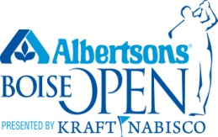 | Albertsons Boise Open  September 12-18  Hillcrest Country Club
 | Basque Block / History Museum & Cultural Center 611 Grove Street
Zoo Boise
Boise Art Museum Boise Greenbelt
Old Boise Oktoberfest

LODGING
Holiday Inn Express
475 W Park Center Blvd
1-208-345-2002
A block of rooms have been reserved at a special rate of $110 + tax for the ROC. Reservations can be made online here or by calling the hotel.
TRANSPORTATION
Boise Shuttle Service operates a free airport shuttle for hotel
partners, including the Holiday Inn Express. Courtesy phone available at the airport.
Boise Green Bike – $5 coupon offer available for guests to use for sight seeing
DINNER
Payette Brewing Company
733 S Pioneer Street
Join us for a behind the scenes brewery tour of Idaho’s largest craft beer maker and dinner provided by one of Boise’s beloved food trucks.

